**Coalfire Technical Challenge**

**INFRASTRUCTURE DEPLOYMENT DETAILS**

**GitHub URL for the modules:**

VPC: <https://github.com/temkebei/awsvpc>

EC2: <https://github.com/temkebei/awsec2>

S3 : <https://github.com/temkebei/awss3>

ALB: <https://github.com/temkebei/awsalb>

ASG: <https://github.com/temkebei/awsasg>

**GitHub URL for the over infra deployed file:**

<https://github.com/temkebei/awsinfra-coalfire>

Overview:

All the Infra and AWS services are developed and deployed using the Terraform modules. For every resource best practices are followed during the implementation like NACL for subnets, Restricted SG for the EC2 and LB, Subnets are deployed in the different AZ’s.

Architecture Overview:

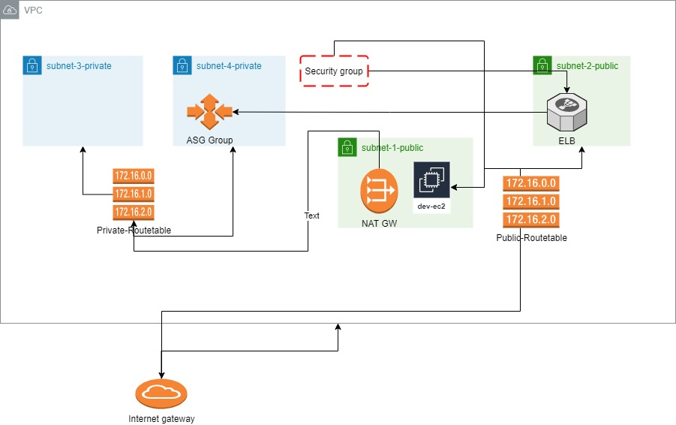

Screenshots:

VPC

1. VPC

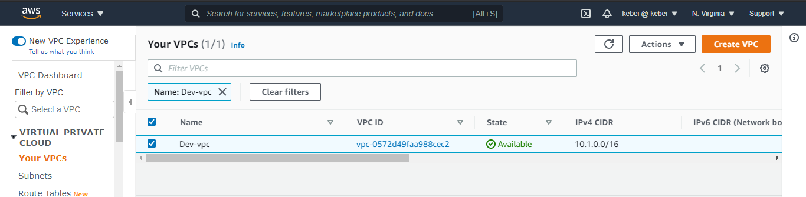

1. Subnets

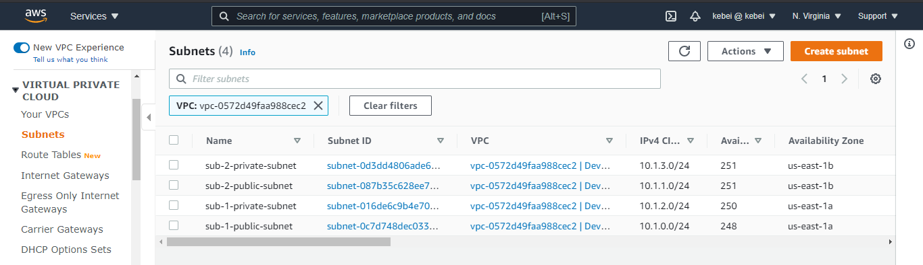

1. Route Tables

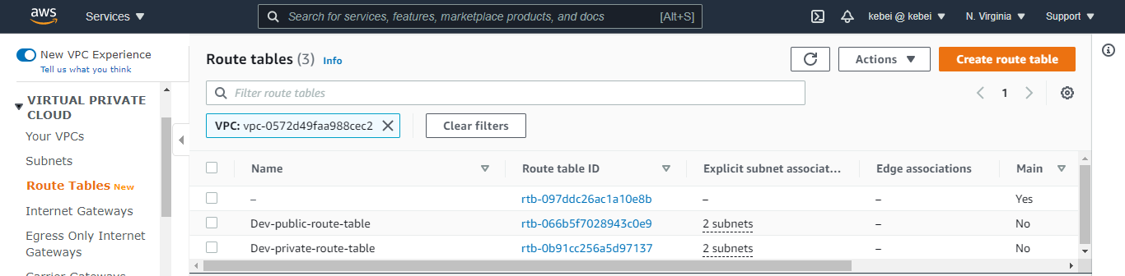

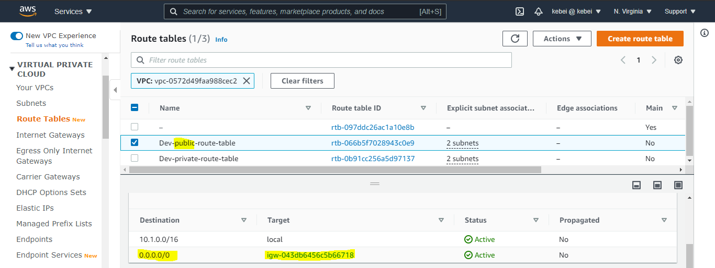

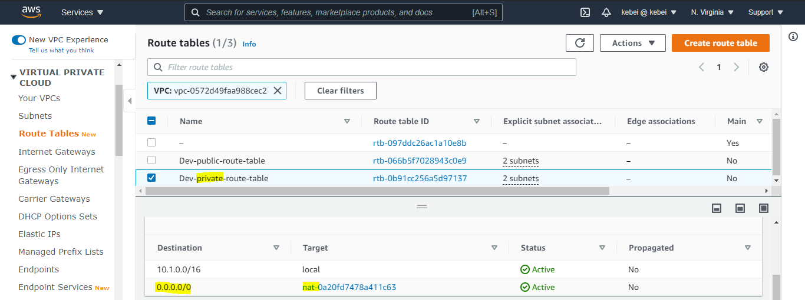

1. Network ACL Implemented for the subnet.

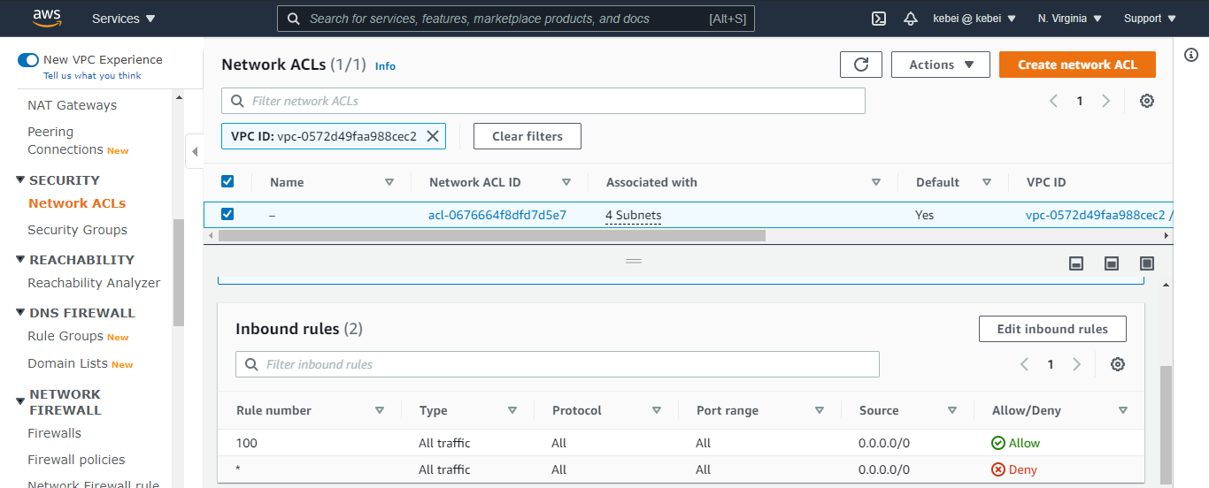

EC2 IN THE SUBNET2:

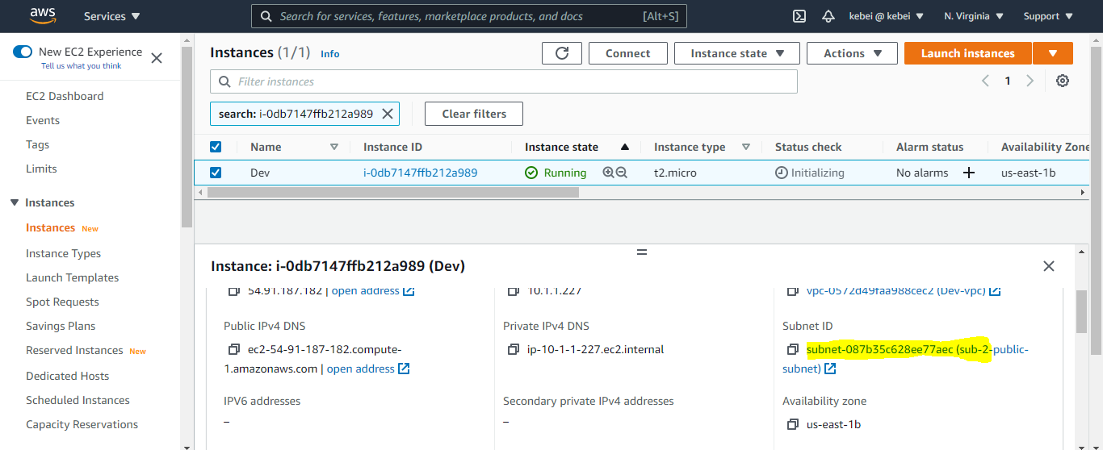

1. Root Volume 20 GB

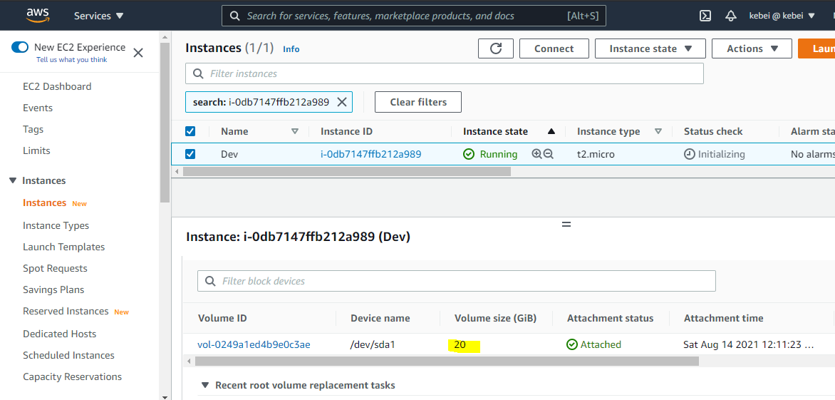

1. Logged in into the Red hat EC2

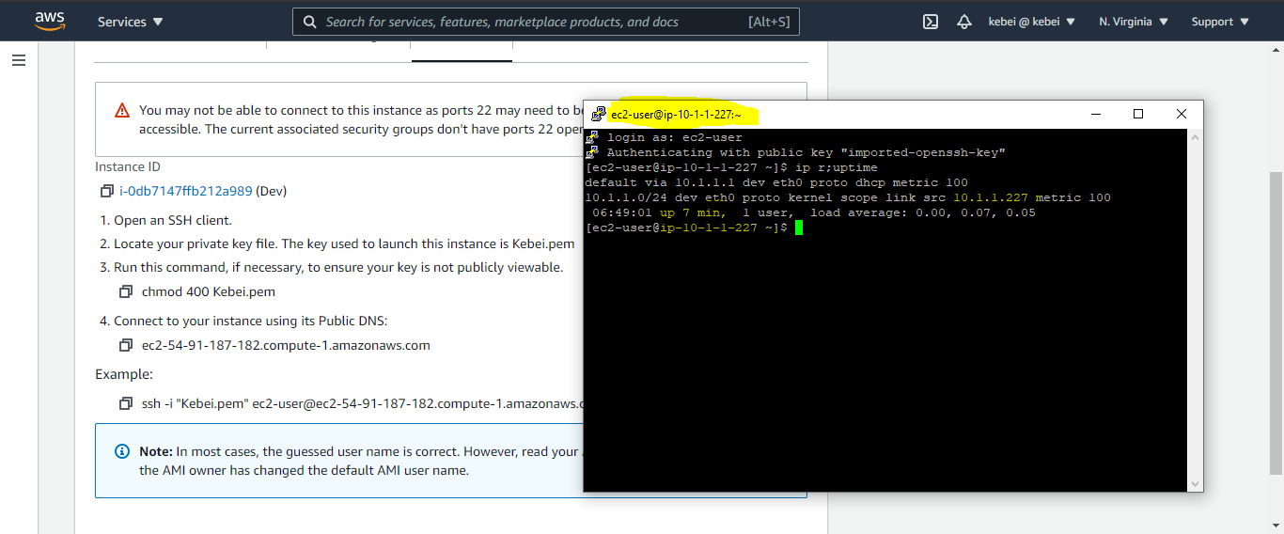

**AUTO SCALING IN SUBNET 4:**

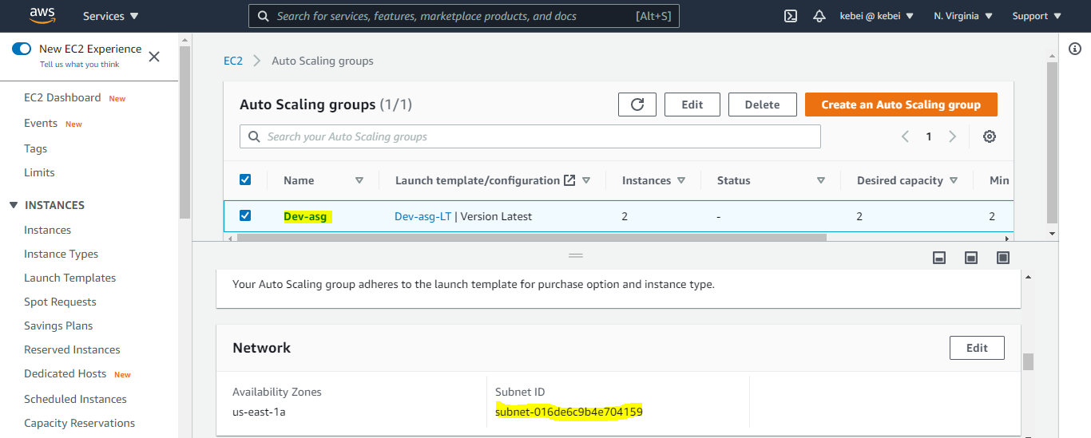

1. Capacity of the ASG Minimum 2 and Maximum 6

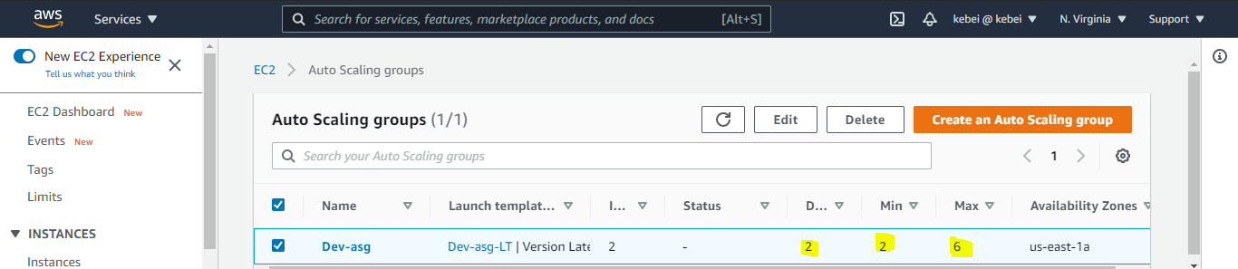

1. Load balancer attached to ASG

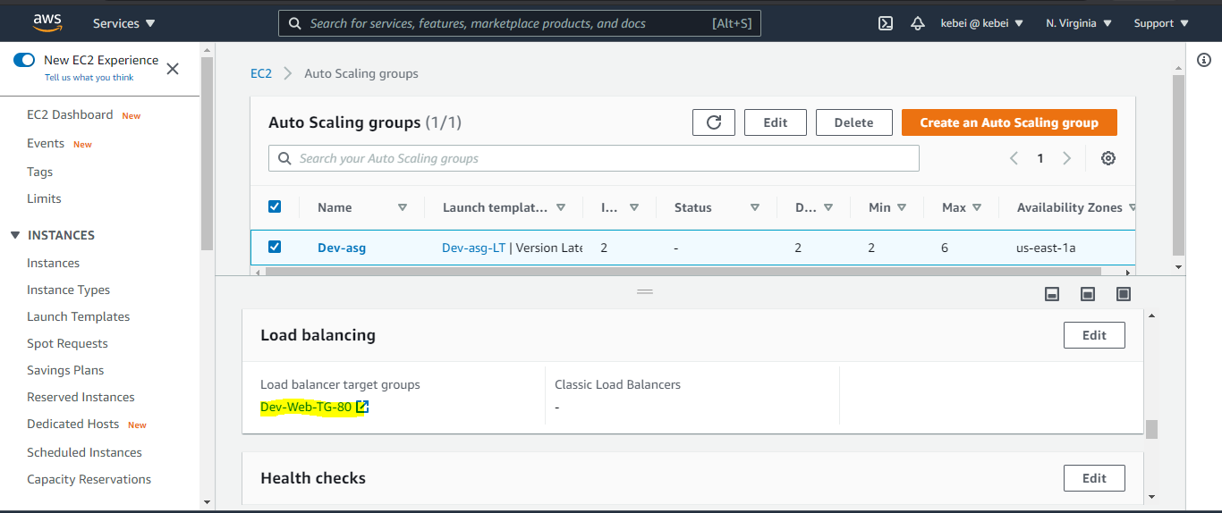

1. ASG Launch Template to install the apache webserver

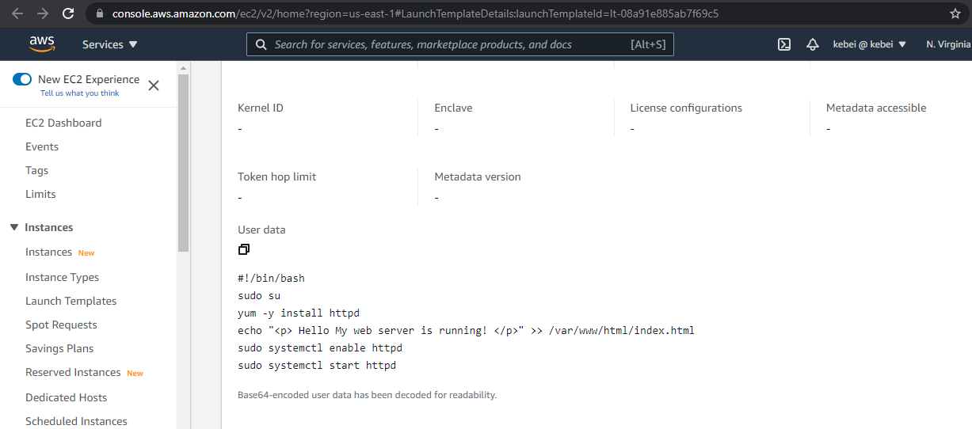

1. Launch Template instance Type and Rehat AMI

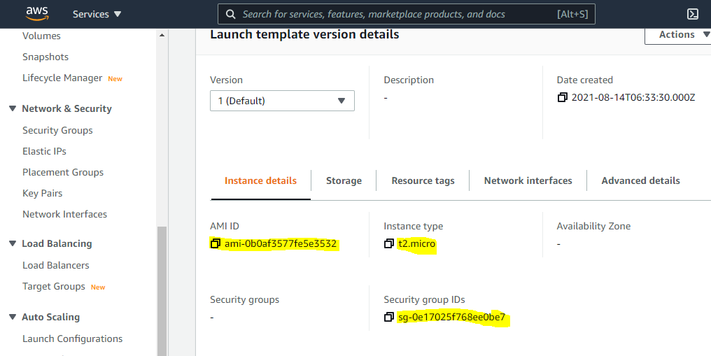

**LOAD BALANCER**

1. Listener on port 80 and forward the traffic to instance in subnet 4

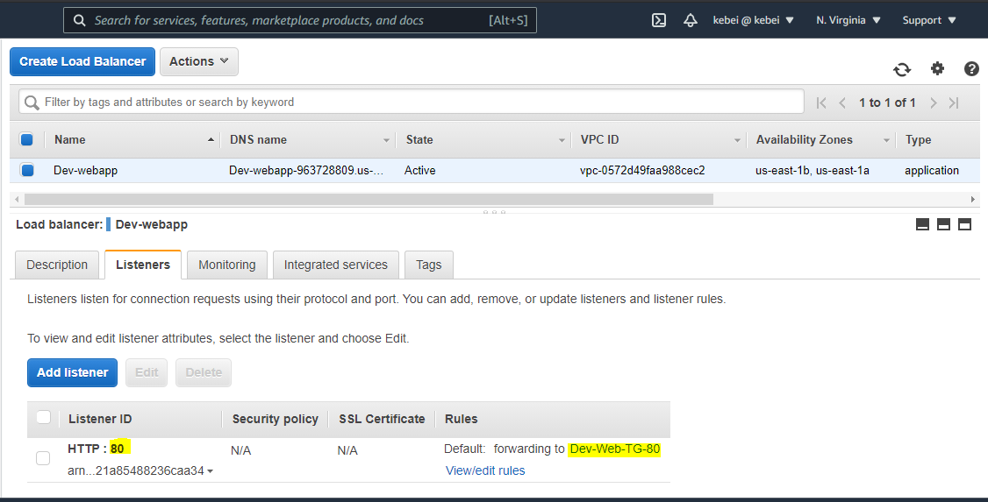

1. Target group containing subnet4 instance

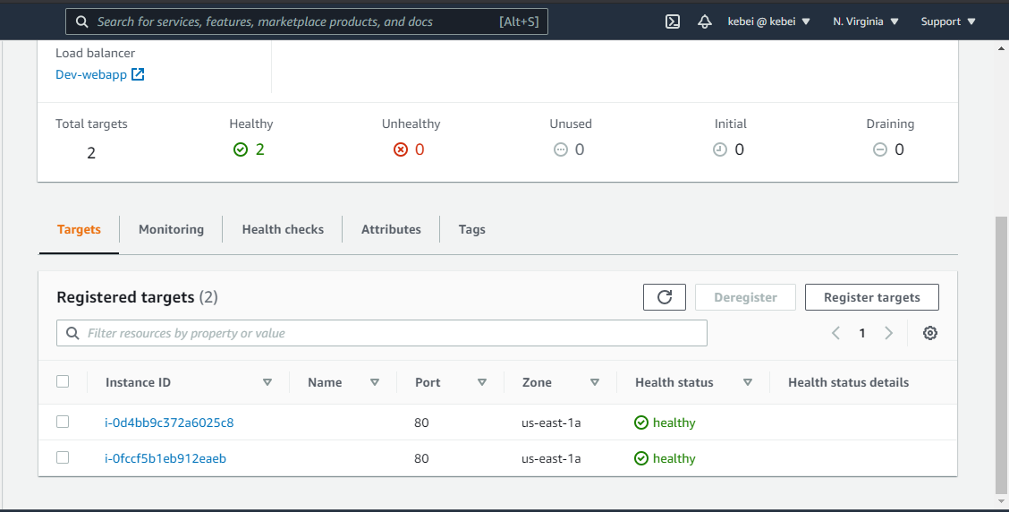

S3

1. S3 Bukcket created

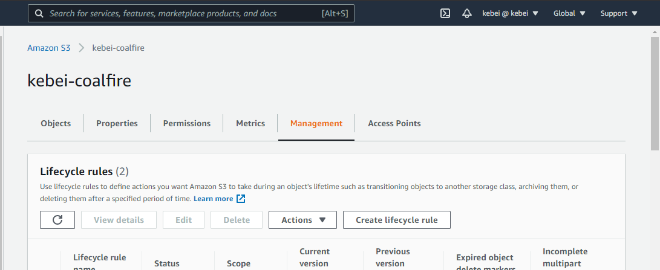

1. Lifecycle configured to move images folder to glacier after 90 days

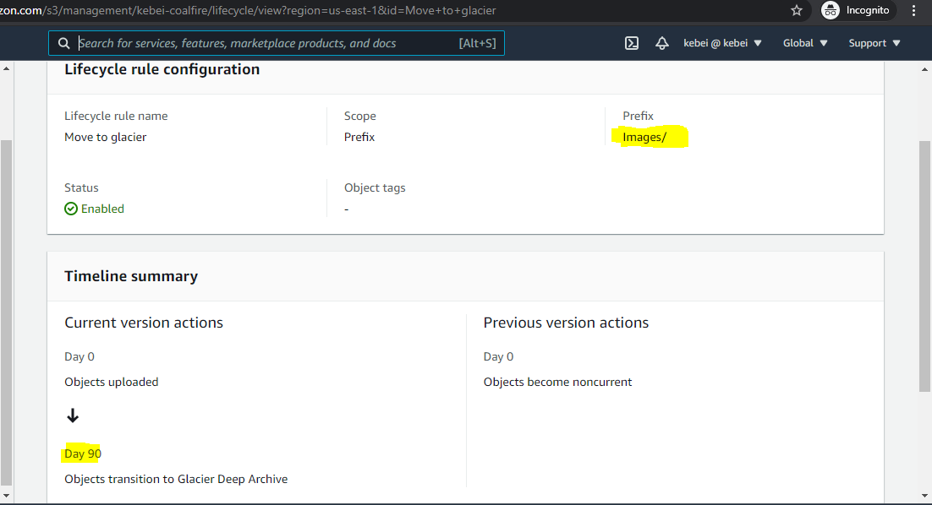

1. Lifecycle configured to clear Logs folder after 90 days.

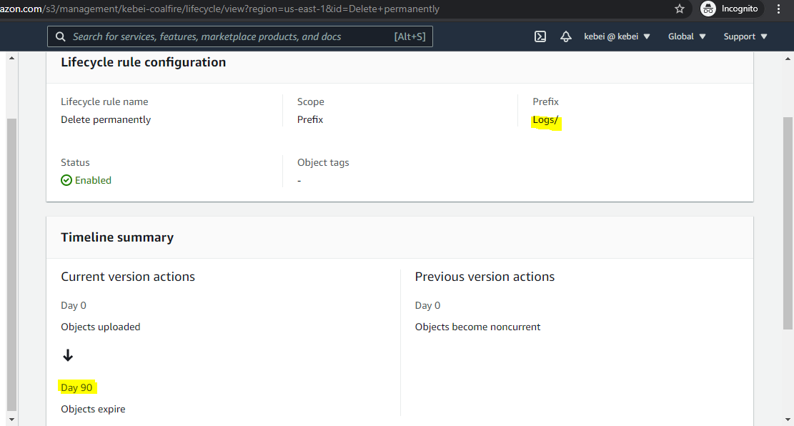

References:

1. <https://registry.terraform.io/providers/hashicorp/aws/latest/docs>
2. <https://registry.terraform.io/modules/terraform-aws-modules/security-group/aws/latest>